AL_sig

FC_sig

AL_sig_mu

FC_sig_mu

Filtered_AL

Filtered_FC

AL_sig

FC_sig

AL_sig_mu

FC_sig_mu

Filtered_AL

Filtered_FC

EDITTING IN PROGRESS:

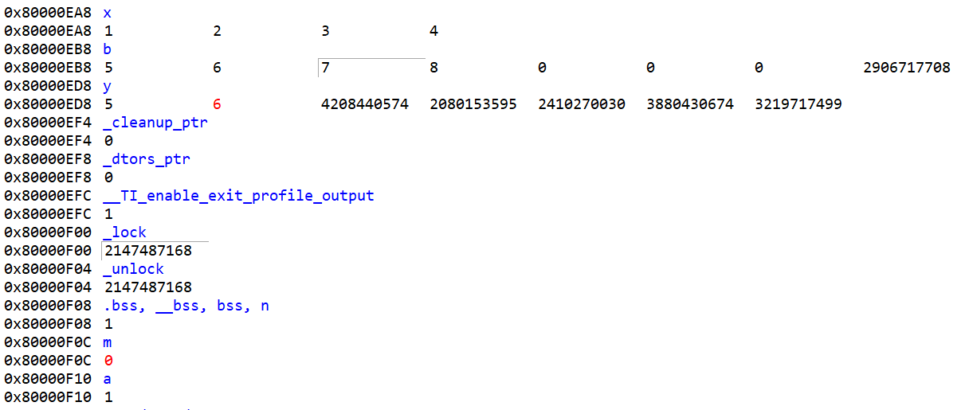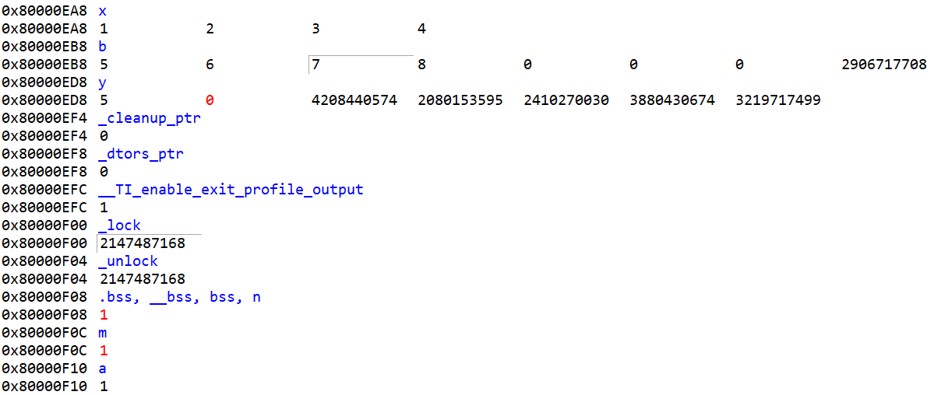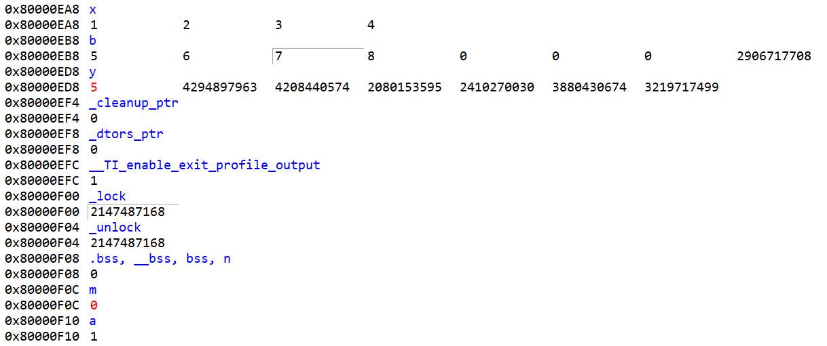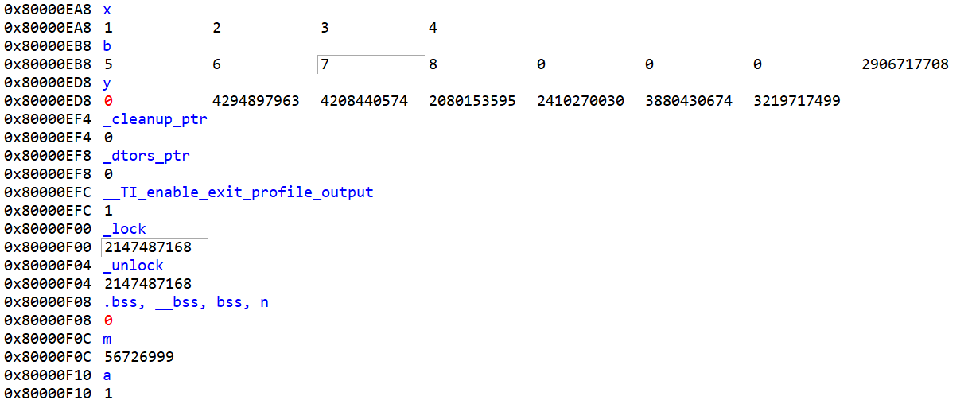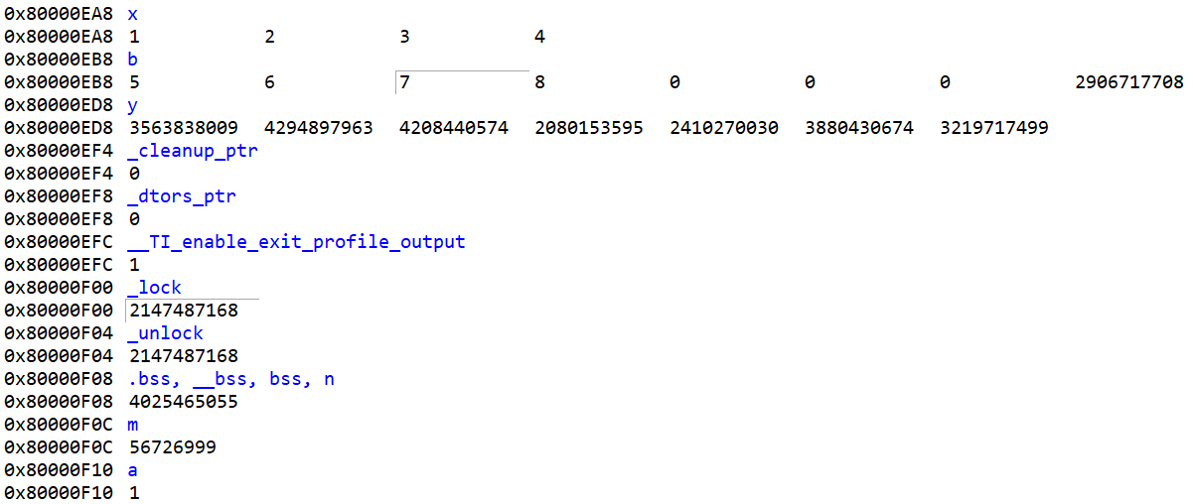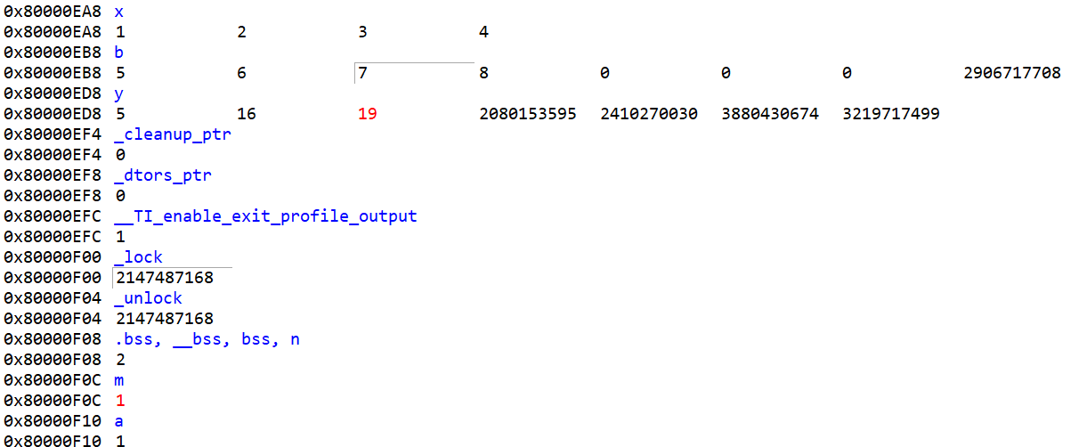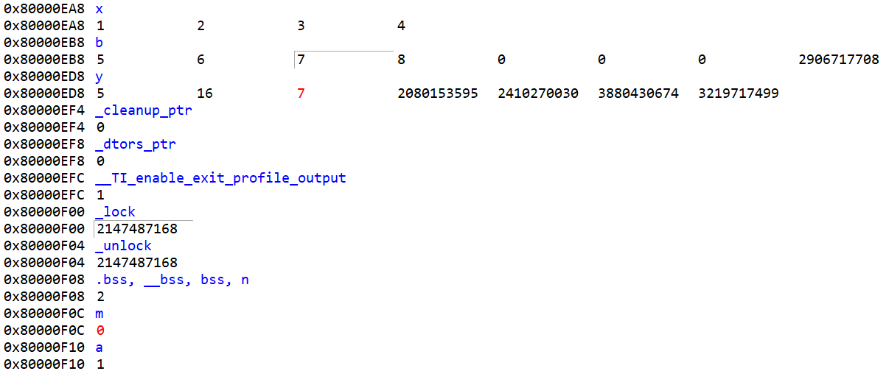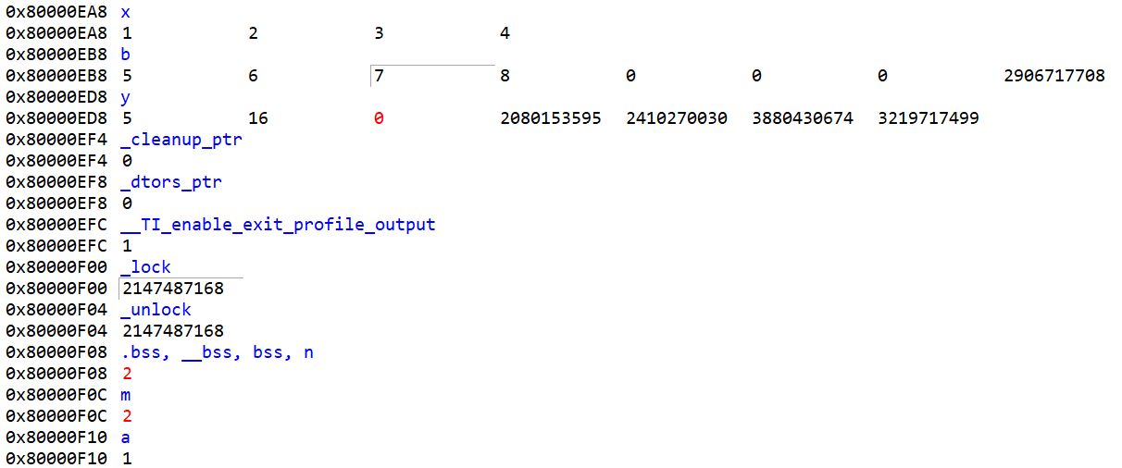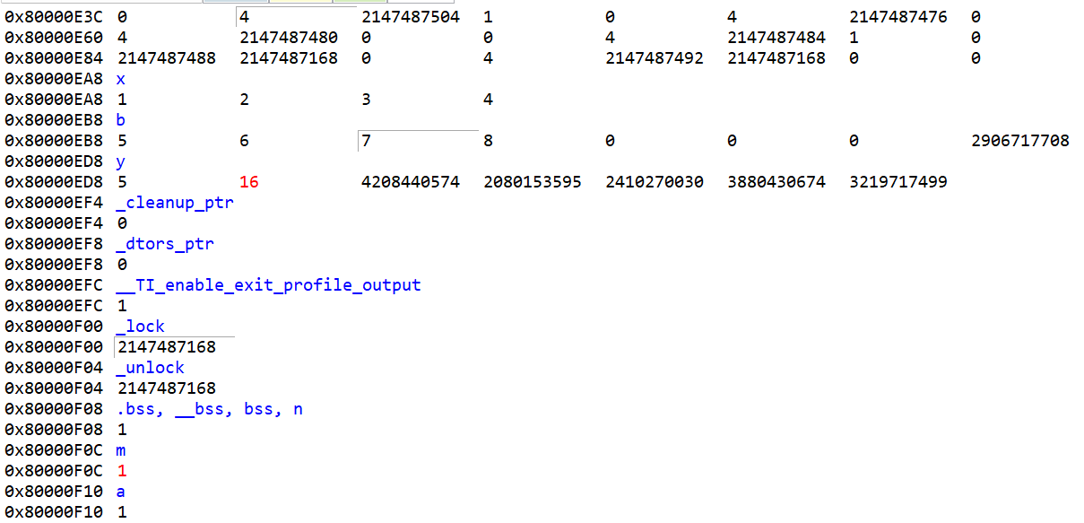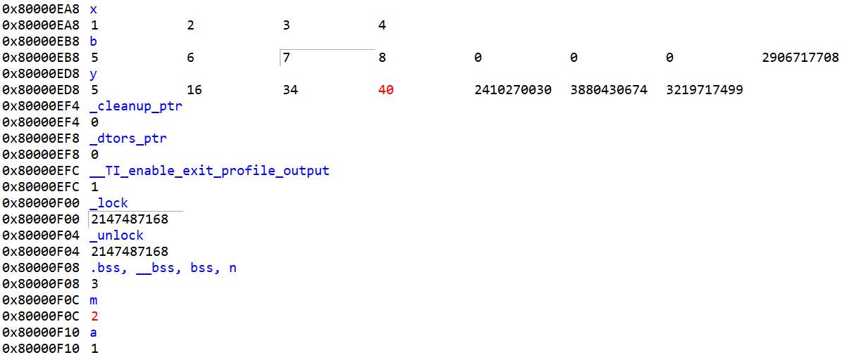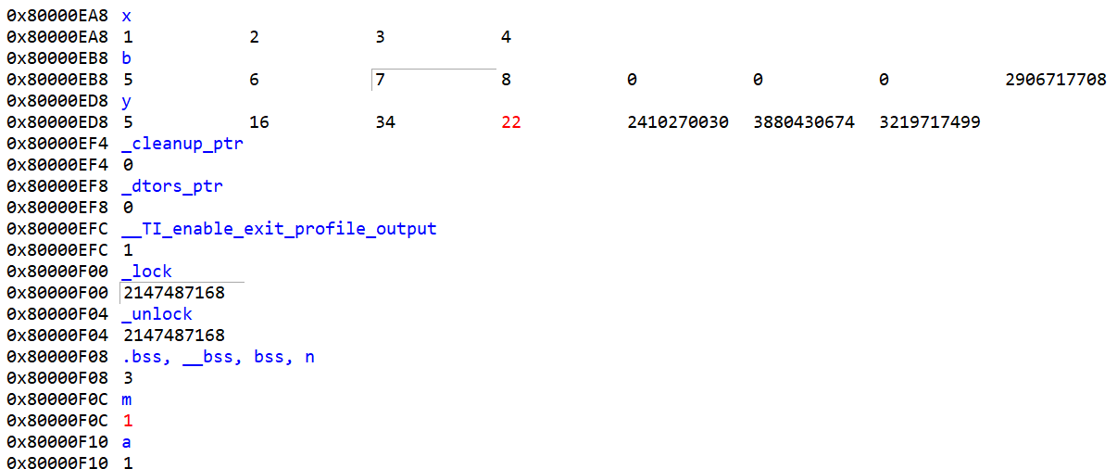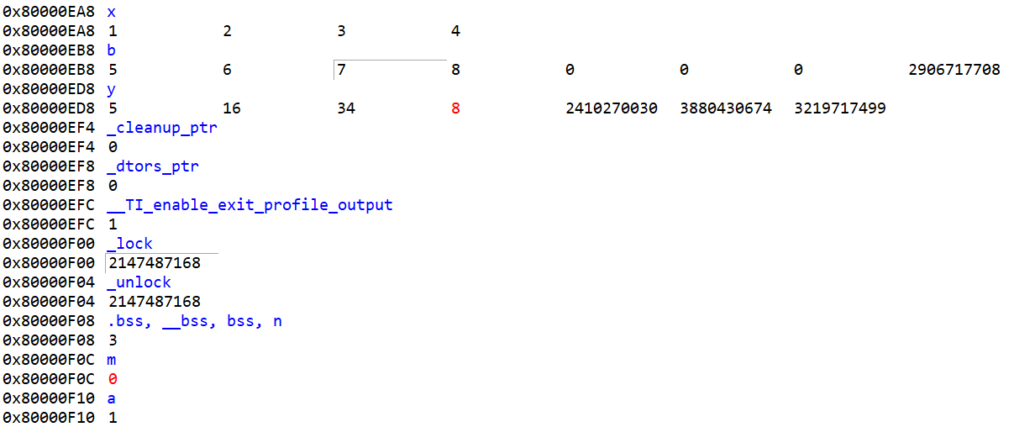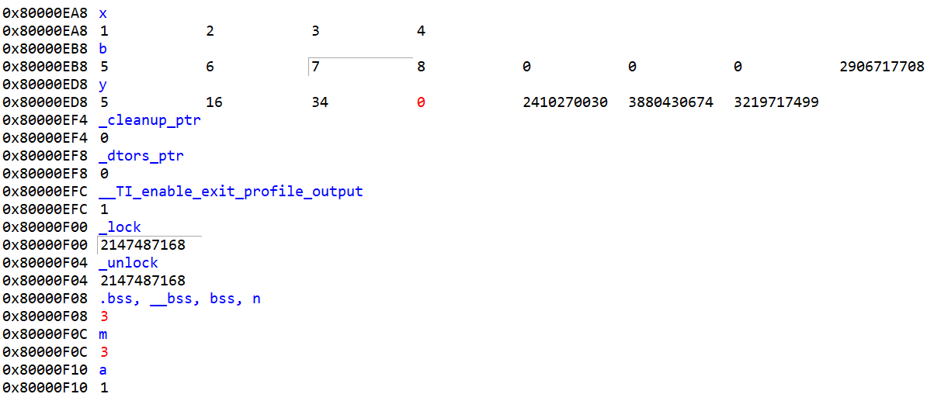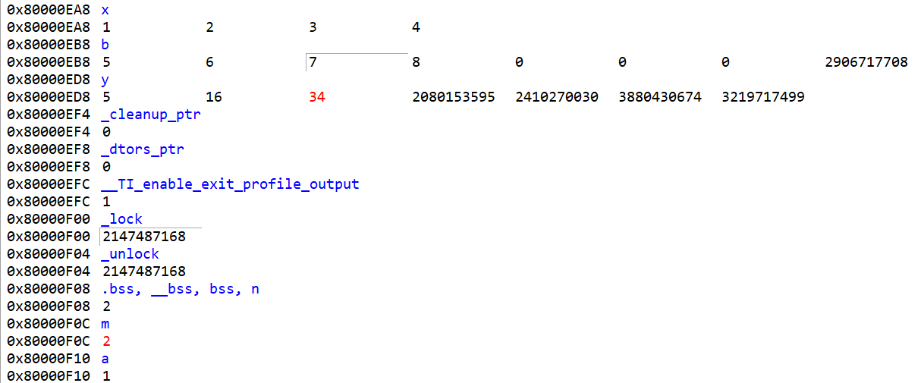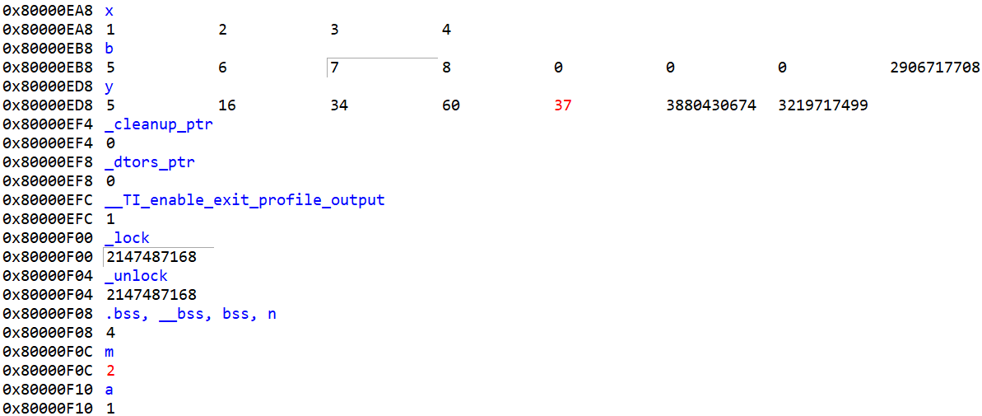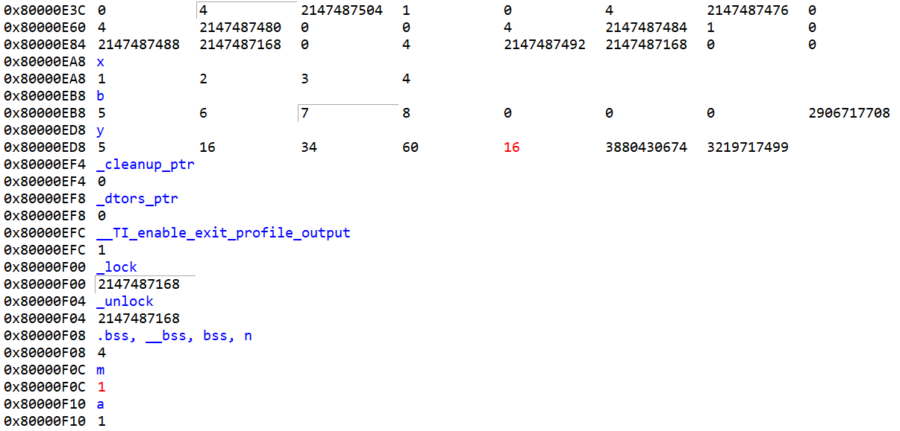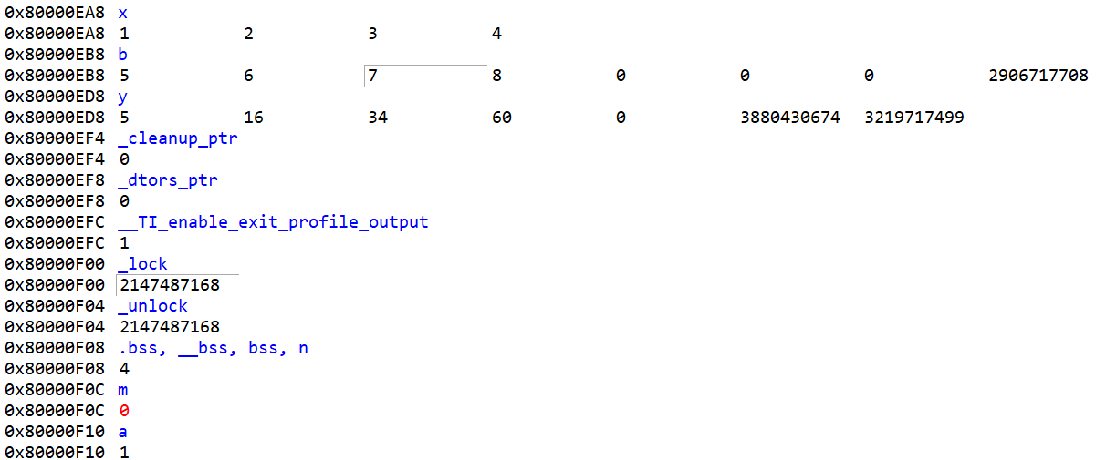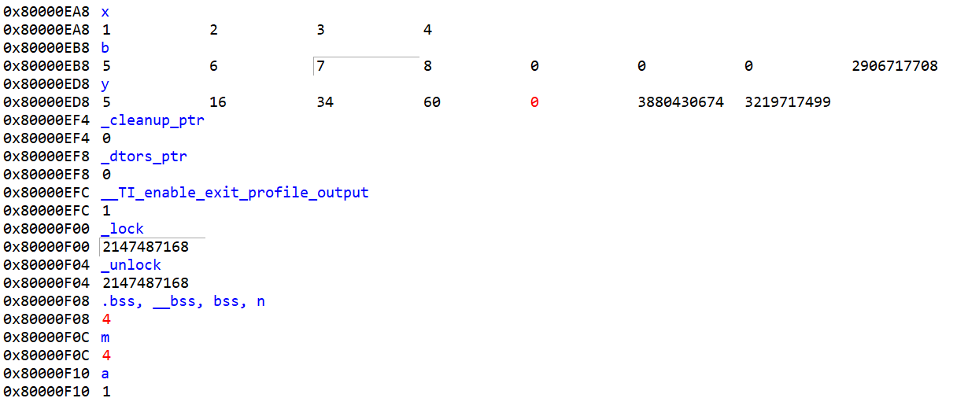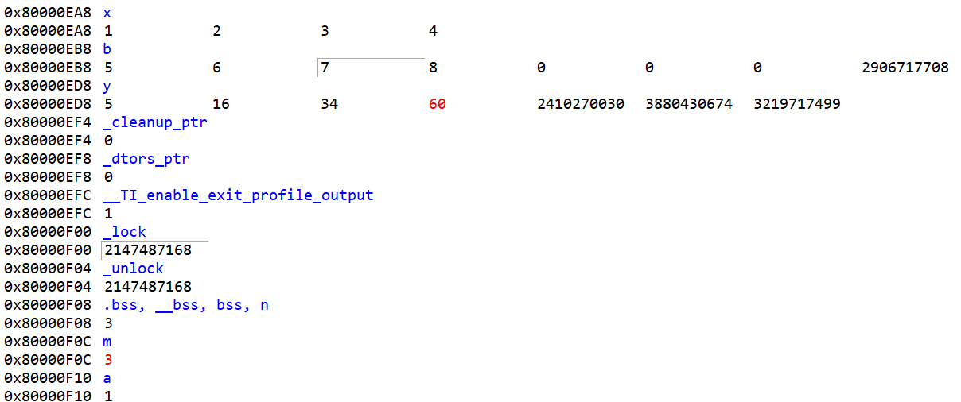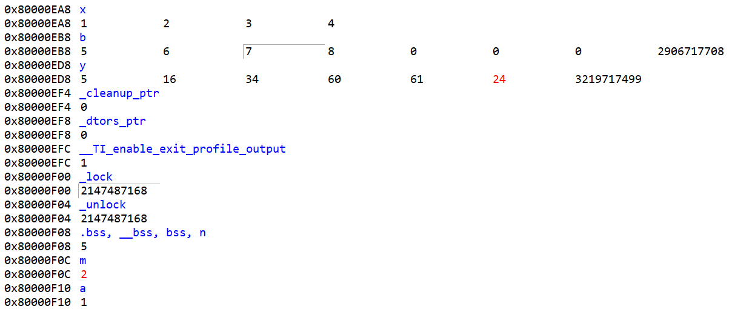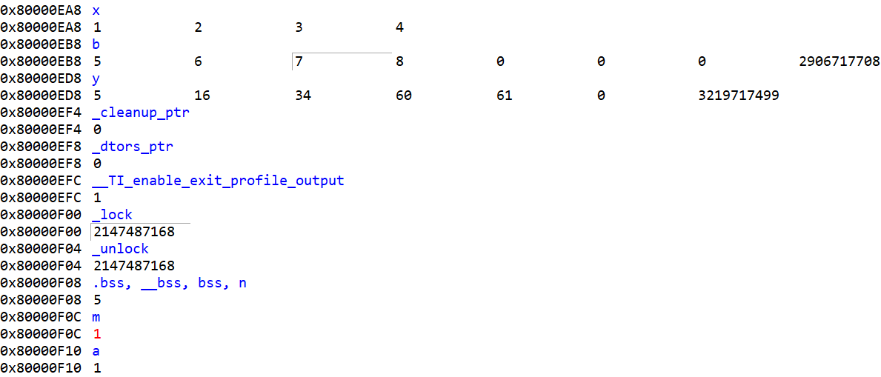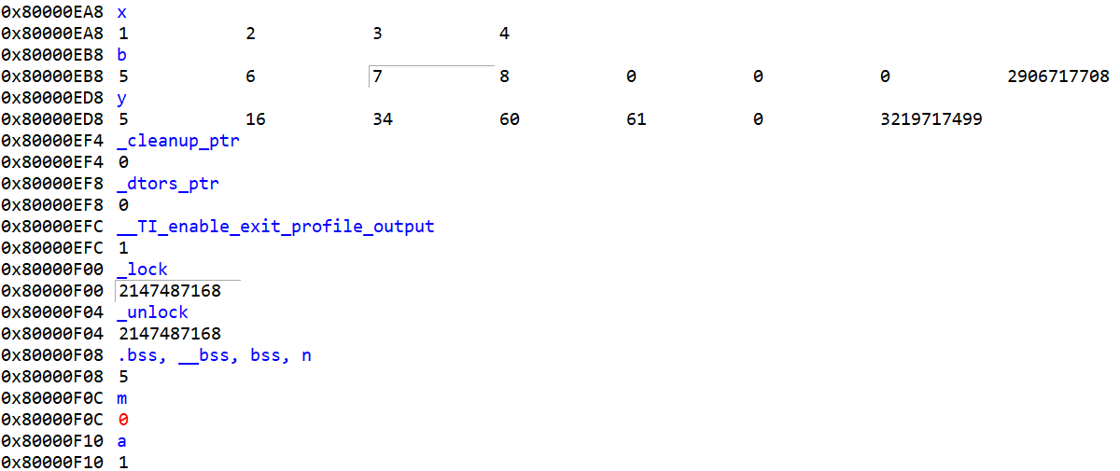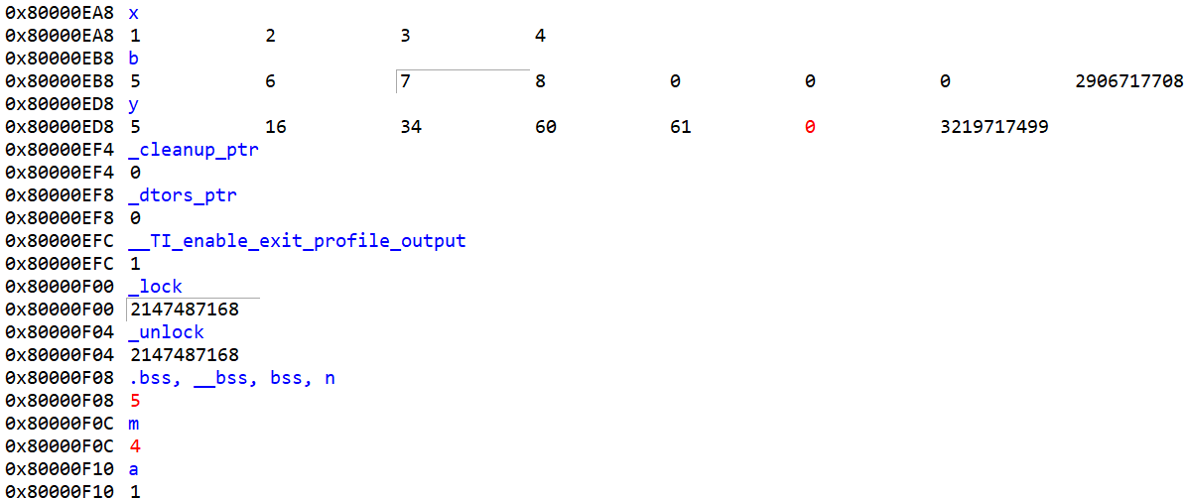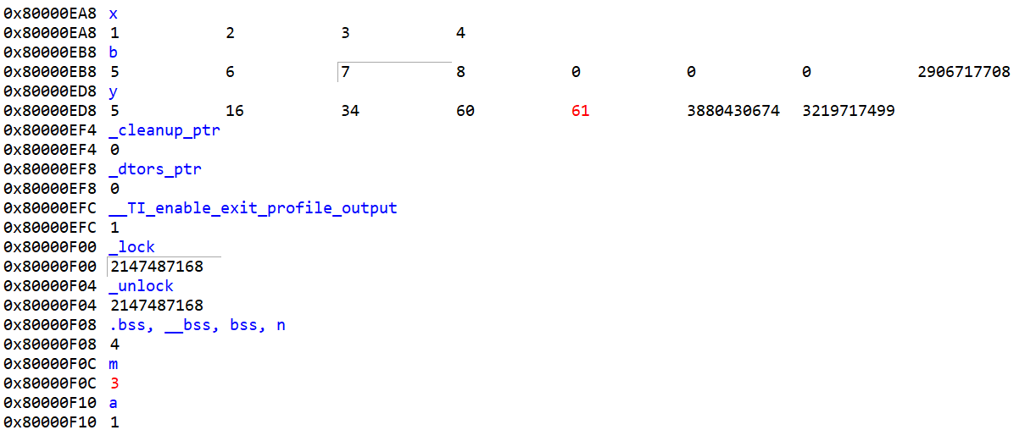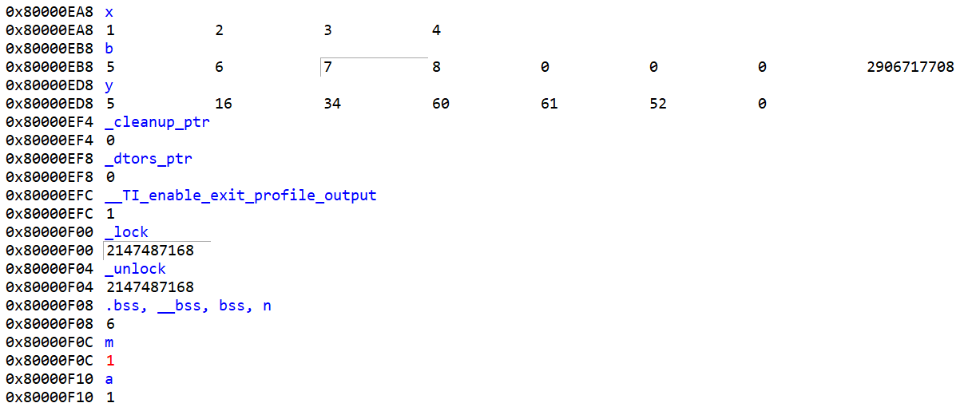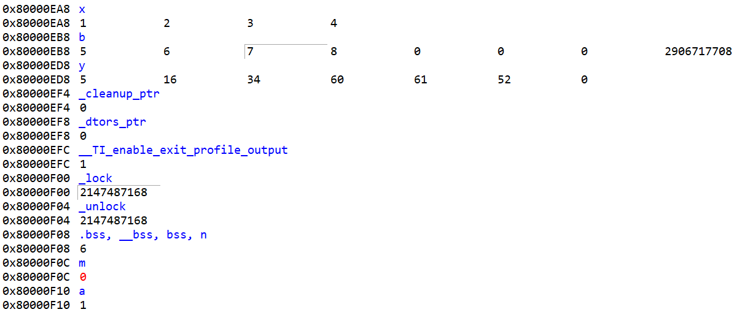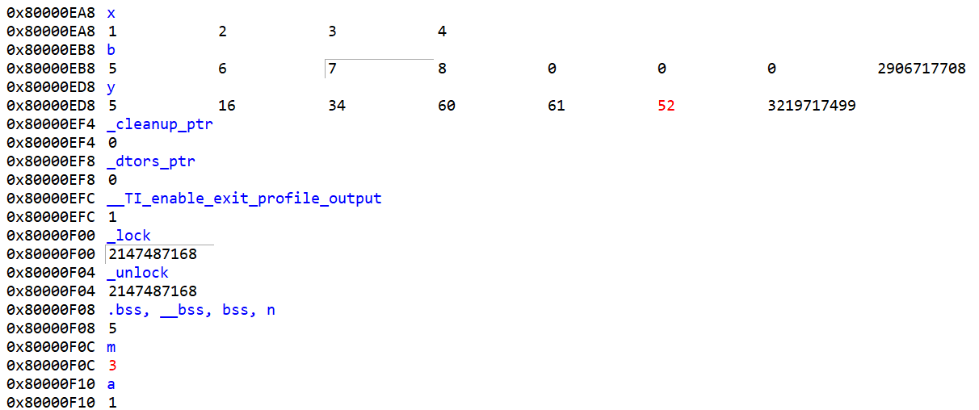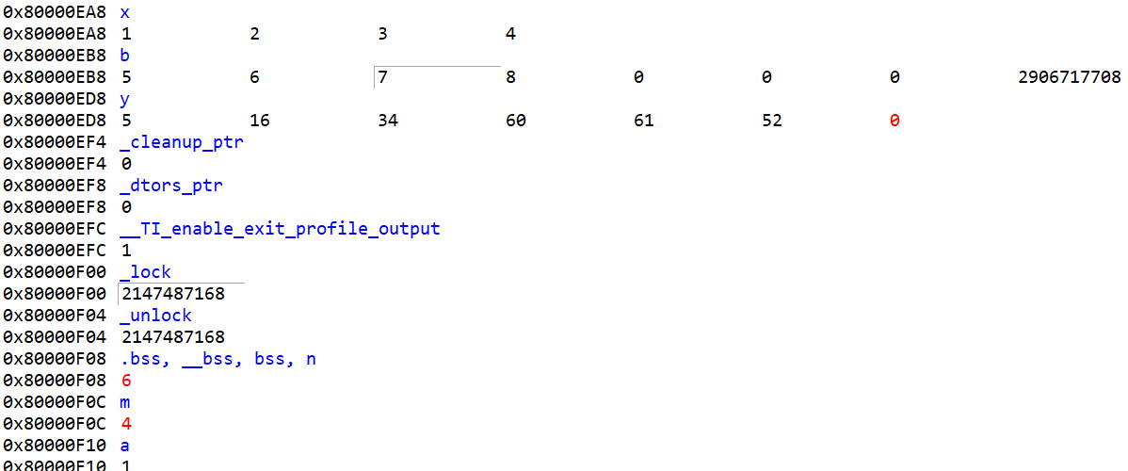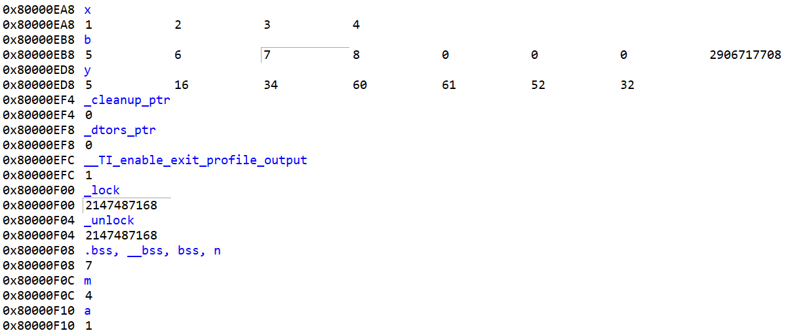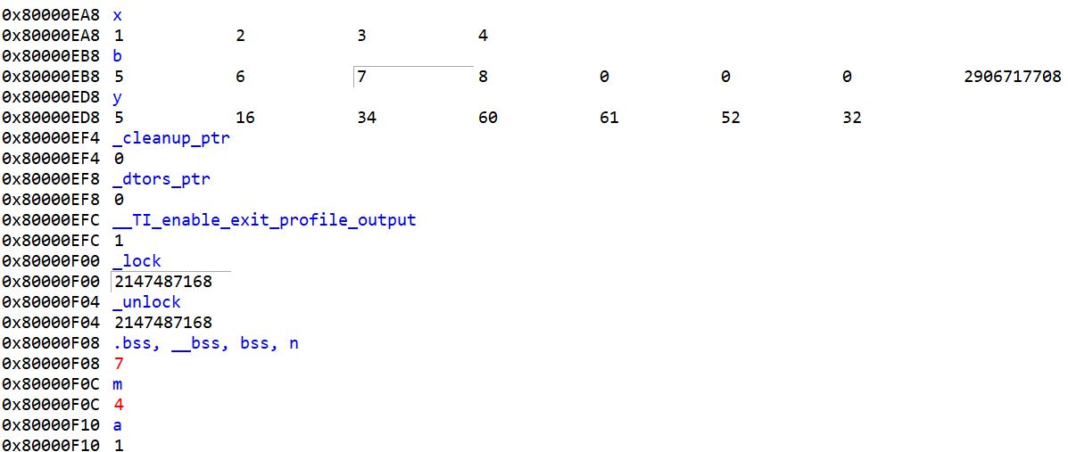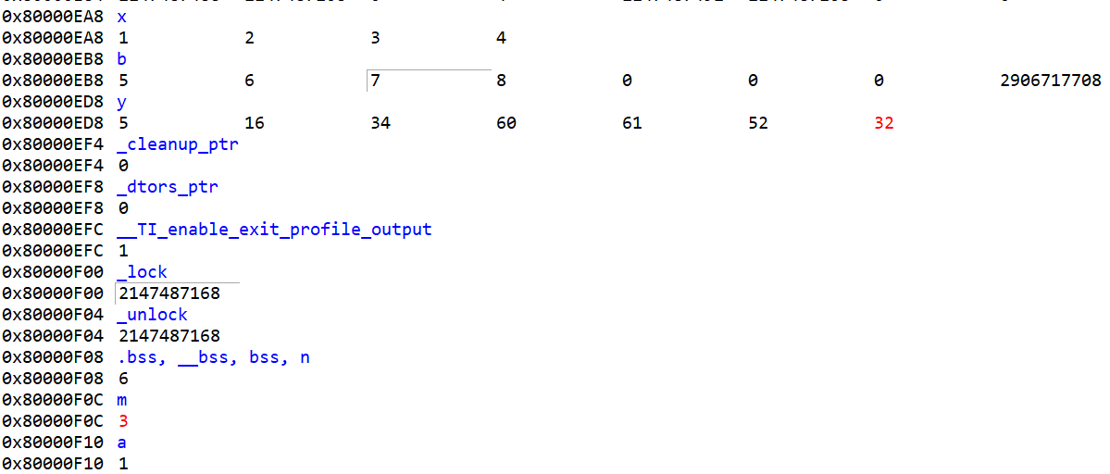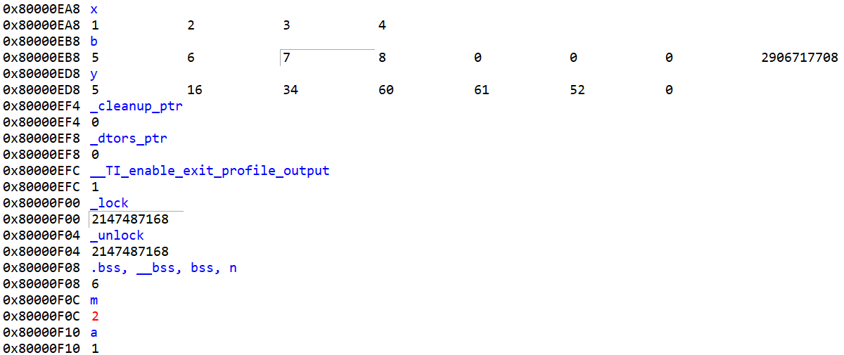

EDITTED:

